**NEWS PHONE APPLICATION**

Project Management Plan

COP 4331 Section 1

Fall 2010

**GROUP 8**

Karl Banks

Aaron Birencwaig

Andrew Harmic

Jason Heintz

Stephen Rodriguez

Tyler Zaino

UNIVERSITY OF CENTRAL FLORIDA

**PROJECT MANAGEMENT PLAN**

|  |  |  |  |
| --- | --- | --- | --- |
| Modification history: | | | |
| **Version** | **Date** | **Who** | **Comment** | |
| v1.0 | 09/13/10 | Andrew Harmic | Initial Template Modifications | |
| v1.1 | 09/21/10 | Andrew Harmic | Complete | |

1 Project Overview

In recent years, smart phones have gained popularity. It is predicted that in the next few years most of the users will access the internet on their mobile devices.

We will create an Android application for the popular news website CNN.com.

It will provide "almost" the same amount of information as its non-mobile counterpart.

2 Reference Documents

* Concept of Operations

3 Applicable Standards

* Coding Standard
  + We will follow the Java coding standard: Code Conventions for the Java Programming Language
* Document Standard
  + All deliverables will follow the templates found on the following webpage: http://www.eecs.ucf.edu/courses/eel5881/ProjectTemplates.html
* Artifact Size Metric Standard
  + We will not follow any set standard at this time.

4 Project Team Organization

The project team consists of Karl Banks, Aaron Birencwaig, Andrew Harmic, Jason Heintz, Stephen Rodriguez, and Tyler Zaino. No single group member will take on the role of project manager. Instead, we will collectively share the responsibility. We have elected to delegate the work for each artifact as a team. Each artifact will have one or two managers. Here is the current artifact management list:

* Concept of Operations
  + Tyler Zaino
* Project Management Plan
  + Andrew Harmic
* Test Plan
  + Stephen Rodriguez
* Software Requirements Specification
  + Aaron Birencwaig
  + Jason Heintz

Karl Banks is responsible for the group website and the compilation of all deliverables into a single PDF file. Currently, communication will consist of informal meetings after class where we can quickly discuss key project details. Email will serve as the primary form of communication.

5 Deliverables

|  |  |
| --- | --- |
| **Artifact** | **Due Dates** |
| Meeting Minutes | N/A |
| Individual Logs | Weekly via email or in class meetings |
| Group Project Management Reports | Biweekly if necessary |
| Concept of Operations | 09/23/10 |
| Project Plan | 09/23/10 |
| Software Requirements Specification | 09/23/10 |
| High-Level Design | 10/26/10 |
| Detailed Design | 10/26/10 |
| Test Plan | 09/23/10 |
| User's Manual | 11/30/10 |
| Final Test Results | 11/30/10 |
| Source, Executable, Build Instructions | 11/30/10 |
| Project Legacy | 11/30/10 |

6 Software Life Cycle Process

We will use the waterfall model with prototyping. We have decided on this model because we are not experienced developing Android applications. Prototyping will be useful for verification and validation during the test phase.

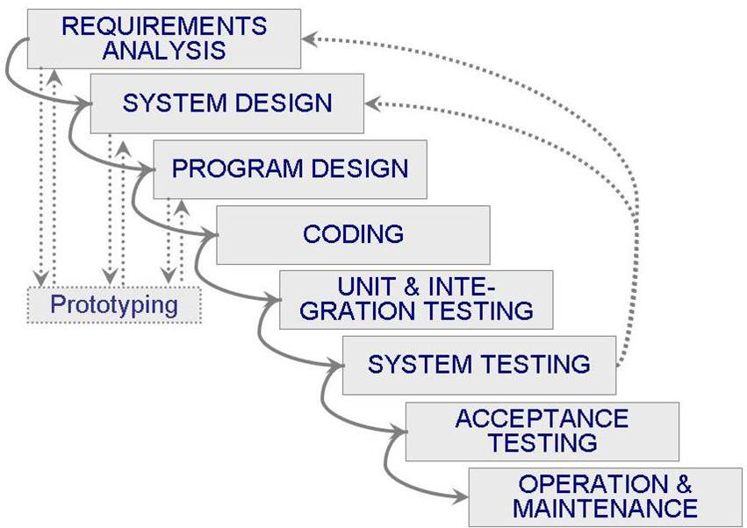

7 Tools and Computing Environment

* Windows OS
* Java Programming Language
* Eclipse Classic 3.5.1 or higher
* JDK 6
* Android SDK
* Android 2.2 Platform
* Android Development Tools (ADT) Plugin for Eclipse

8 Configuration Management

We will use Subversion to handle version and change control. Karl will be responsible for managing the version control software and repository. Every team member should make an effort to learn Subversion and the general procedures for working with a version control system. If we have difficulty using Subversion, we will resort to email to ensure that every team member has the most recent version of the project.

9 Quality Assurance

Each team member is responsible for testing their own code. Modules and any necessary code will be tested by the team before being added to the main project.

Any prototype built during development will not serve as the final product.

If possible, the team will meet with the client and update the project's progress. A possible demonstration of a functional prototype will make sure that we as a team are meeting the client's specifications. Also, it will allow the client to give feedback and specify any functionality that should be added or removed.

10 Risk Management

We do not see any apparent risk(s) that will prevent project completion at this time. Any risk identified during development will be updated ASAP.

11 Table of Work Packages, Time Estimates, and Assignments

|  |  |  |
| --- | --- | --- |
| **Work Package** | **Time Estimate (weeks)** | **Assignment** |
| Initial Documentation | 4 | Team |
| High-level Design | 2 | Team |
| Detailed Design | 2 | Team |
| Prototyping Phase | 12 | Team |
| Coding Phase | 3 | Team |
| Testing Phase | 1 | Team |
| Final Documentation | 4 | Team |

12 PERT Chart

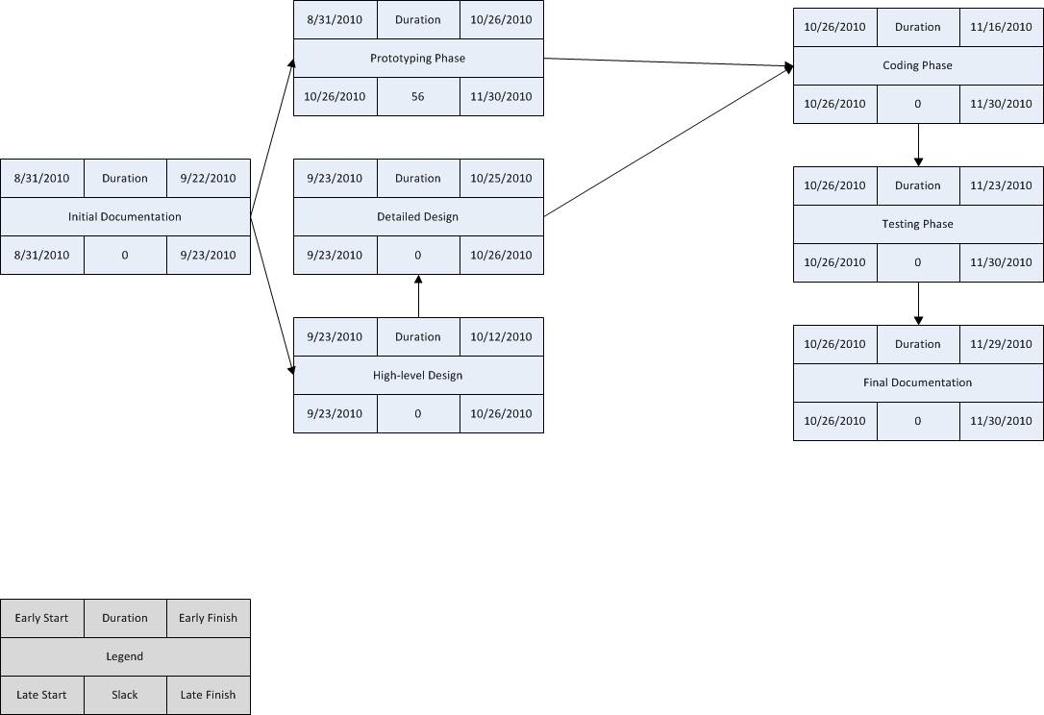

13 Technical Progress Metrics

* Requirements Phase
  + Number of requirements
  + Number of requirement changes
  + Number of TBDs
* Analysis and Design Phase
  + Number of UML diagrams
  + Number of revisions completed
* Detailed Design and Coding Phase
  + Number of classes
  + Number of methods
* Test Phase
  + Number of test cases
  + Number of passing/failing requirements

14 Plan for Tracking, Control, and Reporting of Progress

Team members should share the following information weekly via email or in class meetings: individual time and activity log, individual status information, individual issues and problems, and individual defect log.

Each week, the team will: read and analyze the logs; examine the technical content of the work done to date; examine the technical progress metrics; consider the QA results; reassess the potential project risks, if any; and take corrective action if necessary.

If project management becomes a problem, the team will issue a Project Management Report on the schedule as indicated in the deliverables section above. At a minimum, the Project Management Report will be generated every two weeks and will include the following information: 1 sentence description of overall status, 1 or 2 sentence of any planned changes to the project plan, graph of planned vs. actual time, graph of planned vs. actual for each technical progress metric, updated PERT chart.